**Computational Guided Inquiry: Investigating Sea Level Rise Impacts in Tacoma, WA**

In the following sections you will learn some decision-making tools that incorporate risk and uncertainty into estimating the damage costs of sea level rise and flooding in Tacoma. To conduct this analysis you will gather data on property values and flood probabilities and apply them to a decision-making framework using economic models.

**Part I. Calculating Marginal Damages from Flooding**

**Open your Excel spreadsheet and look at Table 1 on the ‘MD Table’ tab to see the total number of homes that will be exposed at each level of flooding in Tacoma.**

With higher sea levels come more frequent and higher flood events. One way to estimate the impact of SLR due to ice melt in the Polar Regions is to look at the associated damages from higher flood levels. To start, we need to get an estimate of the total property damage that would occur at each level of flooding. To do this, we need an estimate of housing values in Tacoma that are most exposed to floods.

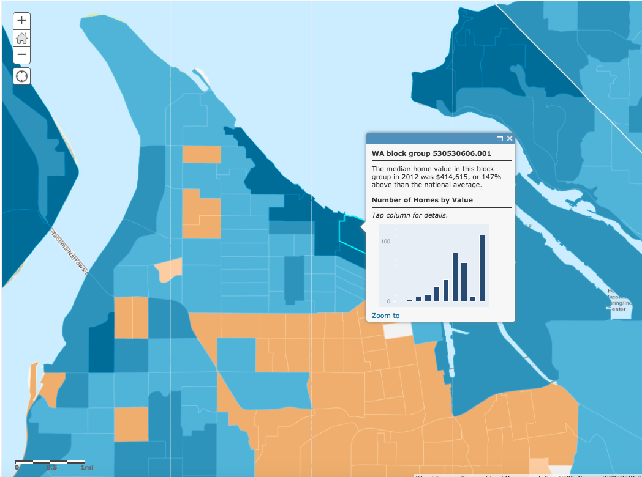

This [link](https://www.arcgis.com/home/webmap/viewer.html?layers=8abd47c2988d497a8f24ad89180980c8) will take you to a map with median home values in the U.S. from 2012 by block group. **[1]**

**Click the link and zoom in on the map to Tacoma using the ‘+’ button in the upper left corner.**

**Click on a block to see the median home price in that block group for 2012.**

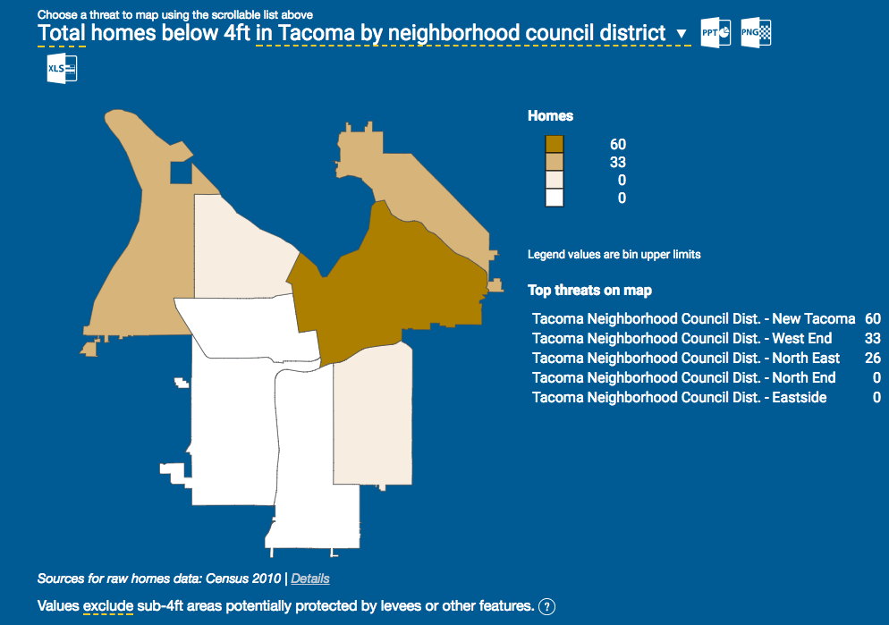

**Now look at the** [**Risk Finder website**](http://riskfinder.climatecentral.org/place/tacoma.wa.us?comparisonType=neighborhood-council-district&forecastType=NOAA2017_inthi_p50&impact=Housing&impactGroup=Buildings&level=4&unit=ft)**[2] for Tacoma and scroll down to see what areas of Tacoma are most at risk due to flooding.**

**Compare these two maps and decide on a median home price to use for the analysis.**

**BACK TO EXCEL**

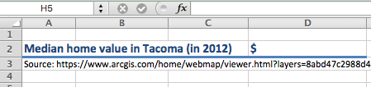**Once you have a price, double click on cell D2. Type the value into your Excel spreadsheet and hit ‘enter’.**

After you type in your median home value in Excel, Columns C and D should populate with the total property damages at each flood level, which is calculated by multiplying the number of houses exposed (Column B) by the median home value you just selected to get the total damages (Column C). Note column D is the total damages in millions.

**Pause for Analysis**

|  |
| --- |
| 1. Justify why you chose to use that home price for this analysis (i.e. what considerations did you make when choosing a median home value?). |
|  |

Now that we have estimates of damage costs, we have to figure out how to use this information. To determine how much an urban center should spend on flood protection, planners need to consider the *marginal* damages done by additional flooding. The **marginal damage of flooding** is the loss in property value that is associated with an additional foot of flooding, or

$$Marginal Damage=\frac{∆Total Property Damage }{∆Feet of flooding}$$

In your Excel spreadsheet, we can calculate the marginal damage from the first foot of flooding by subtracting the change in total damages from 1 to 0 feet of flooding (numerator) over the change in feet of flooding (denominator). Note that changes in flood levels are in 1 foot increments, so the denominator will be “1” for all calculations.

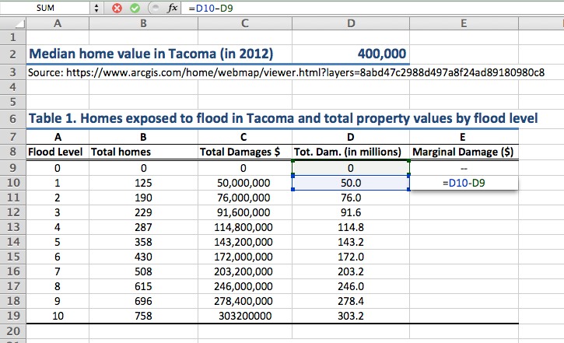

**To subtract the total damages given 1ft of flooding from damages with 0ft of flooding, type the formula ‘=D10-D9’ into cell E10, under the Marginal Damages column then hit ‘enter’.**

Note: you can also *click* on the cell to fill in the cell reference (e.g. D10) instead of typing it.

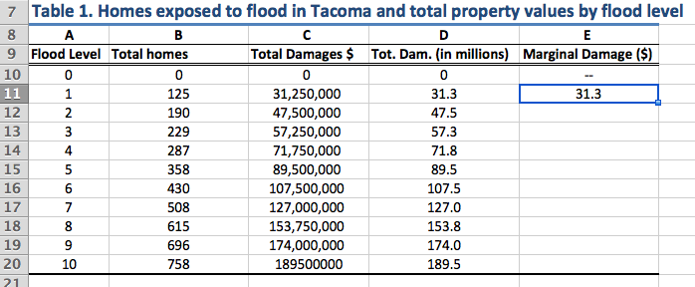

**Next, click on the cell to show the blue border, then click on the square in the lower right corner and drag it down to the last cell in the column to copy the formula into these cells.**

**Pause for Understanding**

|  |
| --- |
| In one sentence, explain what the value in cell (E16) in Table 1 represents. Be as specific as possible. |
|  |

**Part II. Calculating Expected Damages of Flooding**

With climate change comes a lot of risk and uncertainty, both in how much sea levels will rise as well as the maximum flood levels associated with each SLR scenario. One way to incorporate this risk into decision-making is by estimating the **expected value of damages** given the probability that floods will reach a certain height.

For each maximum flood height, there are two possible outcomes: the flood reaches *i* height (for example *i*= 4ft), or the flood does not. Thus there are two probabilities: *pF,4* is the probability of a maximum Flood of 4ft, and *pNF,4* is the probability of No Flood of 4ft.

To calculate the expected marginal damages associated with a 4ft flood, we multiply the probability of the flood, *pF,4*, by the marginal damages that would occur at that flood height, *xF,4*, plus the probability of no flooding at 4ft, *pNF,4*, by the marginal damages, *xNF,4* , which would be zero since there is no flooding. The general formula for each flood level *i*, is:

$$Expected Damage\left(x_{i}\right)=p_{F,i}*x_{F,i}+p_{NF,i}*x_{NF,i} for i=1,2,…,10$$

$$where p_{F,i}+p_{NF,i}=1 for all i$$

Next, we will use this formula to calculate the expected marginal damage (MD) for each flood level for the four different Sea Level Rise scenarios: slow, medium, high, and extreme. Note that since the marginal damages of no flood occurring will always be zero, the second term in the equation drops out, and we only have to calculate *pF,i * xF,i .*

**BACK TO EXCEL**

In **Table 2A**, I have calculated the expected MD for each flood level by SLR scenario for the year 2050. (Note that the marginal damages in column B are the same as the ones you calculated above.)

**Now *you* calculate the expected MD for Table 2B for the Medium SLR scenario. To do this, multiply the marginal damage of flooding (*xF,1* ) by the probability of flooding (*pF,1* ) for a max flood height of 1ft using the formula ‘=B40*E40’ in Excel.**

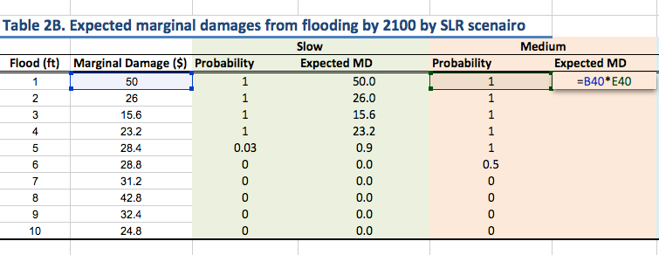

**Then drag down the formula to replicate it in the rest of the column.**

Tables 2A and 2B are now complete. To fill out the rest of Table 2C you will need to get data on the probabilities of flooding at each water level for the year 2150 from the Riskfinder.org website.

**Go to the Risk Finder Tacoma** [**website**](https://riskfinder.climatecentral.org/place/tacoma.wa.us?comparisonType=city-council-district&forecastType=NOAA2017_int_p50&level=4&unit=ft) **and select the ‘Slow rise’ *Sea level scenario* on the right side of the graph and then the 4ft *Water level* on the left side. Hover over the year of interest on the bar chart (2150).**

You see that the probability of a flood of 4ft or more by 2150 is 100% (or 1.0)

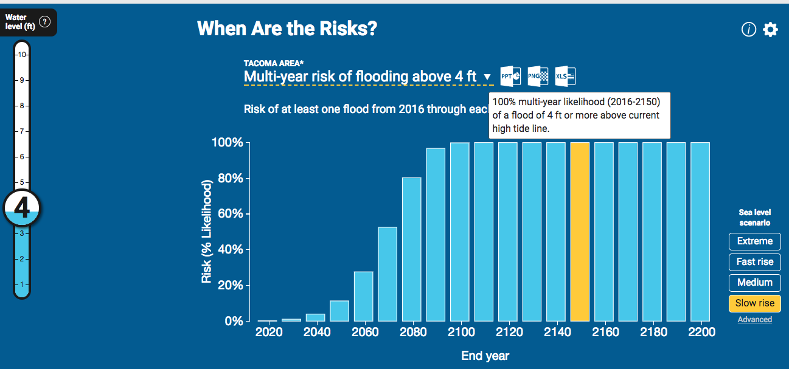

**Do this for each water level to fill in the probabilities in Table 2C for the Slow and Extreme scenarios.**

**Then calculate the expected MDs as you did above in Table 2B.**

**Pause for Understanding**

|  |
| --- |
| In 1-2 sentences, explain what the value in the yellow highlighted cell (D28) in Table 2A represents. Be as specific as possible. |
|  |

**References**

DeConto, R. and Pollard, D. 2016. Contribution of Antarctica to past and future sea-level rise. *Nature*. 531, 591–597. doi:10.1038/nature17145

Hauer, M. E., J. M. Evans, and D R. Mishra (2016). Millions projected to be at risk from sea-level rise in the continental United States. Nature Climate Change.

Murphy, J. October 14, 2015. The Nation. Retrieved from: <https://www.thenation.com/article/3-years-after-hurricane-sandy-is-new-york-prepared-for-the-next-great-storm/>

Hudson, T., Keating, K., and Pettit, A. 2015.Cost estimation for coastal protection – summary of evidence. Environmental Agency. Report –SC080039/R7

National Geographic Magazine. Antarctica is Melting at a Dangerous Pace – Here’s Why. June 22, 2017. Retrieved from <http://video.nationalgeographic.com/video/magazine/170622-ngm-antarctica-melting-sea-levels-climate-change>

NOAA 2017: Sweet, W. V., Kopp, R. E., Weaver, C. P., Obeysekara, J., Horton, R. M., Thieler, E. R., and Zervas, C. (2017). Global and Regional Sea Level Rise Scenarios for the United States. NOAA Technical Report NOS CO-OPS 083.

Parris, A., P. Bromirski, V. Burkett, D. Cayan, M. Culver, J. Hall, R. Horton, K. Knuuti, R. Moss, J. Obeysekera, A. Sallenger, and J. Weiss (2012). Global Sea Level Rise Scenarios for the US National Climate Assessment. NOAA Tech Memo OAR CPO-1. 37 pp.

Sneed, A. 2017. How Is Worldwide Sea Level Rise Driven by Melting Arctic Ice? *Scientific American*. June 5, 2017. Retrieved from: https://www.scientificamerican.com/article/how-is-worldwide-sea-level-rise-driven-by-melting-arctic-ice/

1. ArcGIS US Median home prices for 2012: https://www.arcgis.com/home/webmap/viewer.html?layers=8abd47c2988d497a8f24ad89180980c8
2. https://riskfinder.climatecentral.org/place/tacoma.wa.us?comparisonType=neighborhood-council-district&forecastType=NOAA2017_inthi_p50&impact=Housing&impactGroup=Buildings&level=4&unit=ft